Software Requirements Specification

for

Extracurricular Management System

**Version 1.0**

**Prepared by**

**Group Name: fiesta**

|  |  |  |
| --- | --- | --- |
| **<name>** | **<student #>** | **<e-mail>** |
| **<name>** | **<student #>** | **<e-mail>** |
| **<name>** | **<student #>** | **<e-mail>** |
| **<name>** | **<student #>** | **<e-mail>** |
| **<name>** | **<student #>** | **<e-mail>** |

|  |  |
| --- | --- |
| **Instructor:** | **Dr. N. Harini** |
| **Course:** | **Netcentric Programming** |
| **Lab Section:** | ***<place your lab section here>*** |
| **Teaching Assistant:** | ***<place your TA’s name here>*** |
| **Date:** | **24-09-2020** |

**Contents**

**CONTENTS II**

**REVISIONS II**

**1** **INTRODUCTION 1**

1.1 Document Purpose 1

1.2 Product Scope 1

1.3 Intended Audience and Document Overview 1

1.4 Definitions, Acronyms and Abbreviations 1

1.5 Document Conventions 1

1.6 References and Acknowledgments 2

**2** **OVERALL DESCRIPTION 2**

2.1 Product Overview 2

2.2 Product Functionality 3

2.3 Design and Implementation Constraints 3

2.4 Assumptions and Dependencies 3

**3** **SPECIFIC REQUIREMENTS 4**

3.1 External Interface Requirements 4

3.2 Functional Requirements 4

3.3 Use Case Model 5

**4** **OTHER NON-FUNCTIONAL REQUIREMENTS 6**

4.1 Performance Requirements 6

4.2 Safety and Security Requirements 6

4.3 Software Quality Attributes 6

**5** **OTHER REQUIREMENTS 7**

**APPENDIX A – DATA DICTIONARY 8**

**APPENDIX B - GROUP LOG 9**

**Revisions**

|  |  |  |  |
| --- | --- | --- | --- |
| **Version** | **Primary Author(s)** | **Description of Version** | **Date Completed** |
| Draft Type and Number | Full Name | Information about the revision. This table does not need to be filled in whenever a document is touched, only when the version is being upgraded. | 00/00/00 |

# Introduction

*<TO DO: Please provide a brief introduction to your project and a brief overview of what the reader will find in this section.>*

## Document Purpose

Extracurricular activities are a vital part of the student experience, fostering lifelong skills and providing added value beyond the curriculum. While there is a widely accepted necessity for a Learning Management System (LMS) to assist with the delivery of the curriculum, a large number of schools don’t utilize an [Extracurricular Management System (EMS)](https://en.wikipedia.org/wiki/Extracurricular_activity#Extracurricular_Management_Systems) to operate their extracurricular programs. Instead, Colleges, schools often use a combination of paper, spreadsheets, online forms, SIS modules and other disparate systems. This creates a lack of visibility and often leads to data security risks, as well as inaccurate information.

## Product Scope

The purpose of this document is to present a detailed description of the Extracurricular Management System. An EMS is a purpose-built platform designed to help schools manage the administration of their extracurricular activities. It is a one-stop-shop for extracurricular data and processes, allowing schools to access reporting and analytic’s that they would otherwise be unable to utilize. This document is intended for both the user and developer of the software.

## Intended Audience and Document Overview

* Typical Users, such as students, who want to use Extracurricular Management System (EMS) for checking latest details and managing their data and also by modifying their details for displaying what they want to.
* Advanced/Professional Users, such as project managers, who want to use our EMS for organizing new events, or even modifying any details.
* Marketing staff, who want to use our EMS for show-casing, displaying and rating the upcoming events.
* Programmers who are interested in working on the project by further developing it or fix existing bugs.
* Professors for checking whether it intends to do the right work.

The best suggested flow for the readers is to follow the standard first to last order for more clarity and understanding of our standing and the taken steps for designing the Extracurricular Management System.

The rest of the document discusses about the overall product description such as what our product is intended in doing, and also describing whether our product is a replacement for certain existing systems, or a new, self-contained product. The document also describes the product functionality it’s design and implementation constraints, also the assumptions we took into our considerations by collecting the required dependencies. By also describing the specific requirements of our product whether these requirements are functional or not, and finally we have an appendix.

## Definitions, Acronyms and Abbreviations

* EMS - Extracurricular Management System
* LMS - Learning Management System
* HTML - The standard markup language for documents designed to be displayed in a web browser.
* CSS - describes how HTML elements are to be displayed on screen
* My SQL - The database that will be used for this project

## Document Conventions

This Document was created based on the IEEE template for System Requirement Specification Documents.

## References and Acknowledgments

1) [https://github.com/aehlke/tag-it](https://meet.google.com/linkredirect?authuser=0&dest=https%3A%2F%2Fgithub.com%2Faehlke%2Ftag-it)

2) [bulma.io](https://www.bulma.io)

# Overall Description

## Product Overview

It has been a tradition of conducting cultural activities in schools, colleges and universities, part of academics. Keeping this tradition into practice every year there are like thousands of cultural activities that are being conducted. When this is happening in large number in one way, keeping track of all the events is a tedious job for event organisers and for the people who take part in the event as well. The main objective of this product is to manage different events that are being conducted. Everything works in online mode, starting from admin creating events, students registration to admin updating winners for each event. This product provides extraordinary and user-friendly features like searching for teammate based on a particular skill and at the same a student can keep track of his/her events using google calendar and get remainders accordingly.

## Product Functionality

The product contains functionalities like:

For Student:

* **Public profile**: Profile for the World to view and admire
* **Private profile:** Student can edit his/her personal, achievements & contact details
* **View events**: View Past, present and upcoming events
* **One click registrations** : Solo/Team registrations for Inter/Intra college events
* **Search for teammates**: Find your teammates based on skills
* **Student leaderboard**: Ranks the students based on participation and winning of events
* **View winners of the event:** Event wise winner list
* **Announcements section:** Get to know the latest updates regarding events

For Admin:

* **Add/Remove/Update events**: Full access for event management
* **Generate Report**: Summarize events within a period (weekly, monthly and yearly)
* **View student registrations**: View all registrations in one portal
* **View events details:** Displays details eventwise
* **Event winners announcement**: Declare the winners
* **Student Leaderboard:** Controls how the students are ranked
* **Search students**: Pick the right students based on skills

## Design and Implementation Constraints

Front-end web pages for Fiesta are created using technologies like HTML, JS, CSS and Bulma(a CSS framework). It uses a modular design where every feature is wrapped into a separate module and the modules depend on each other.

## Assumptions and Dependencies

*<List any assumed factors (as opposed to known facts) that could affect the requirements stated in the SRS. These could include third-party or commercial components that you plan to use, issues around the development or operating environment, or constraints. The project could be affected if these assumptions are incorrect, are not shared, or change. Also identify any dependencies the project has on external factors, such as software components that you intend to reuse from another project.*

*TO DO: Provide a short list of some major assumptions that might significantly affect your design.>*

# Specific Requirements

## External Interface Requirements

### User Interfaces

The web app will interface with most browsers, especially Internet Explorer, Firefox and Safari. As long as the user has knowledge to operate a web browser, they will be able to operate our website efficiently.

1. Landing page - 1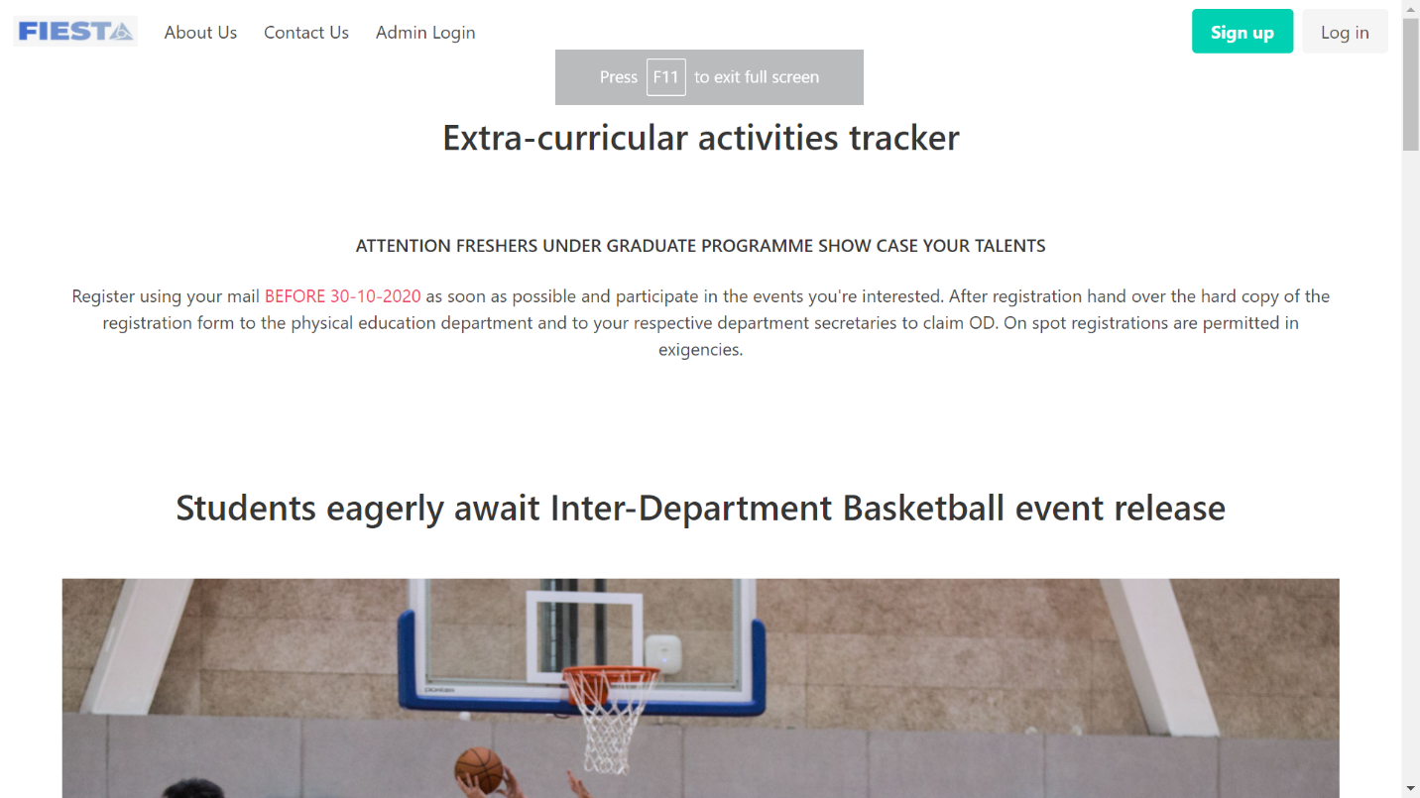
2. Landing page -2 with small descriptions and images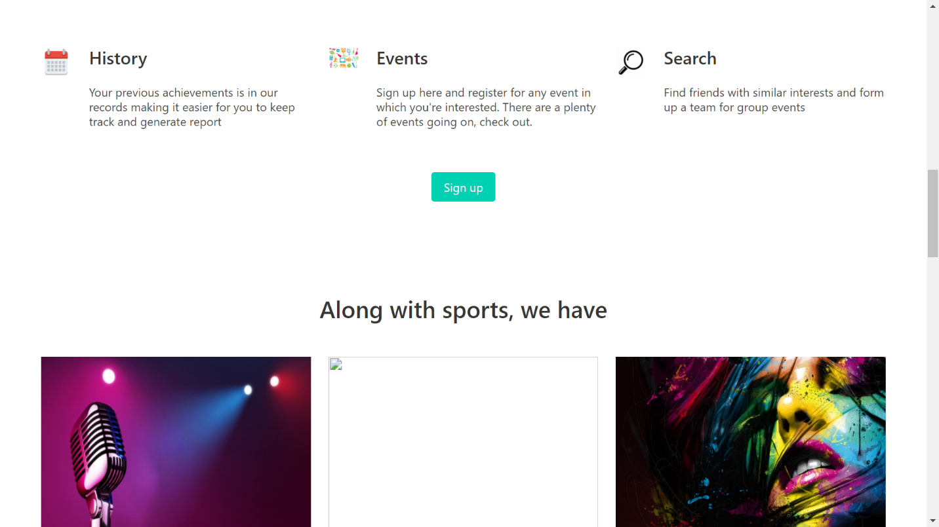
3. Contact Us page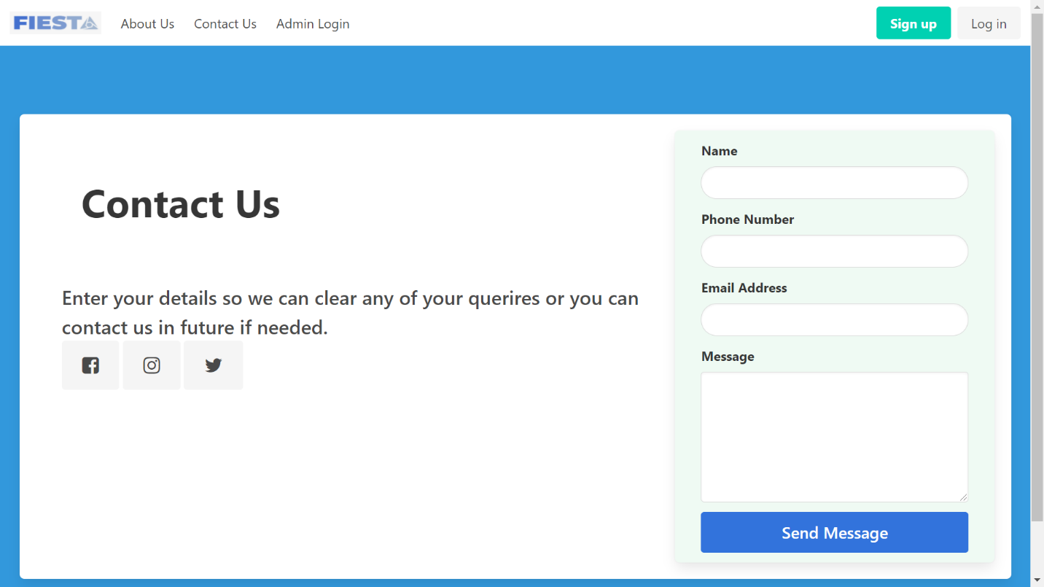
4. Admin login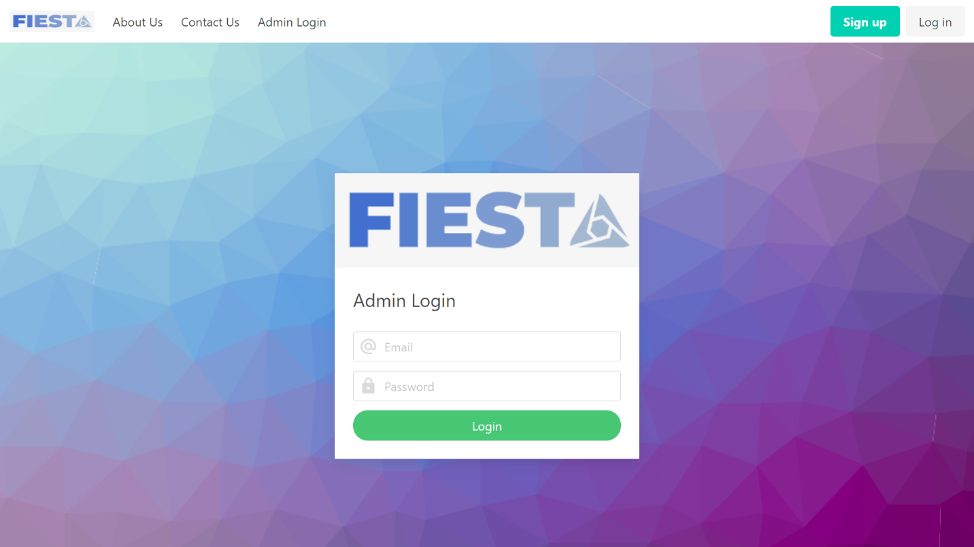
5. Student login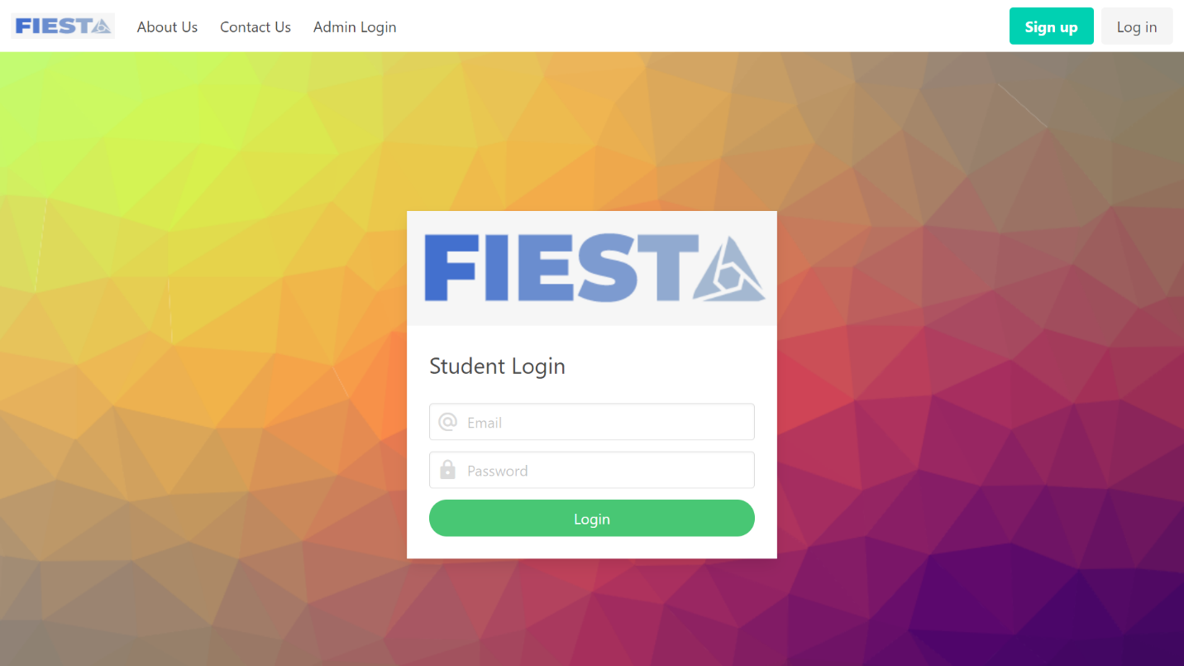
6. Student Registration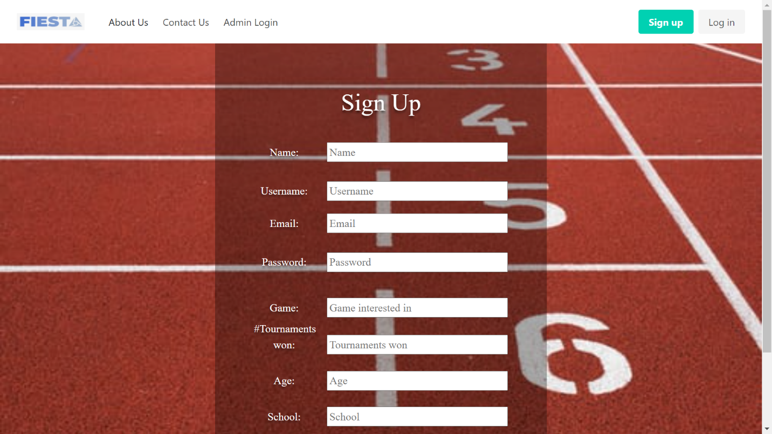
7. Admin Dashboard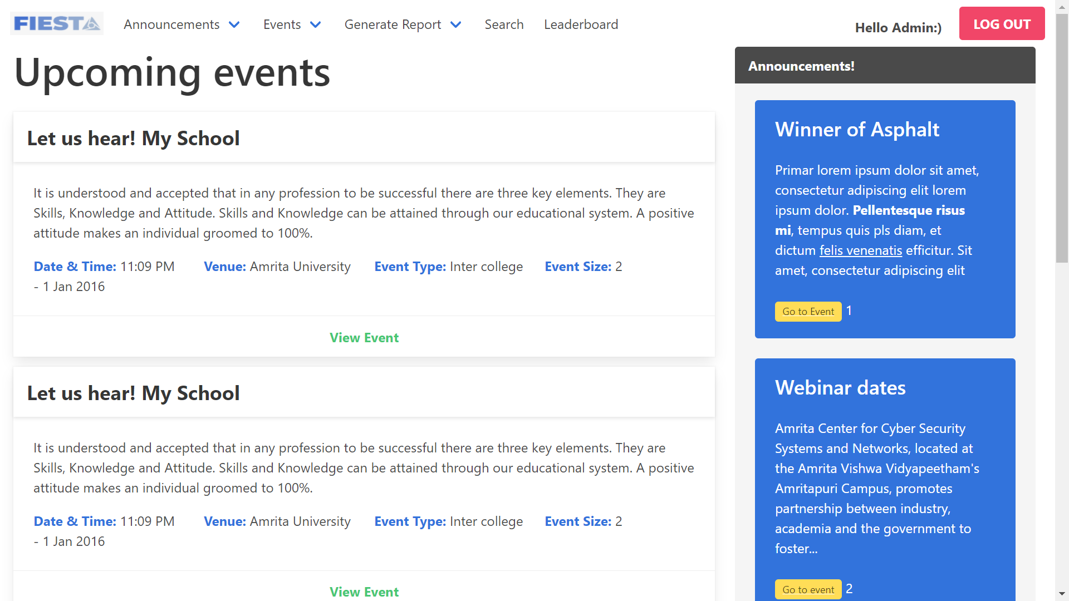
8. Dropdown menu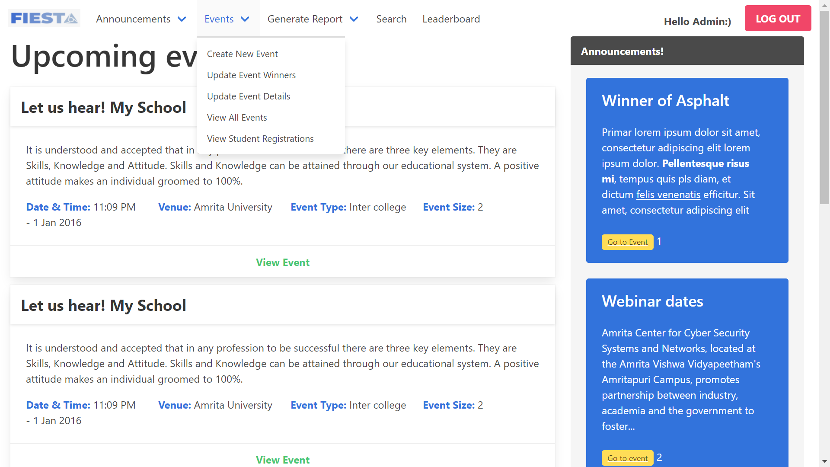
9. Add new announcement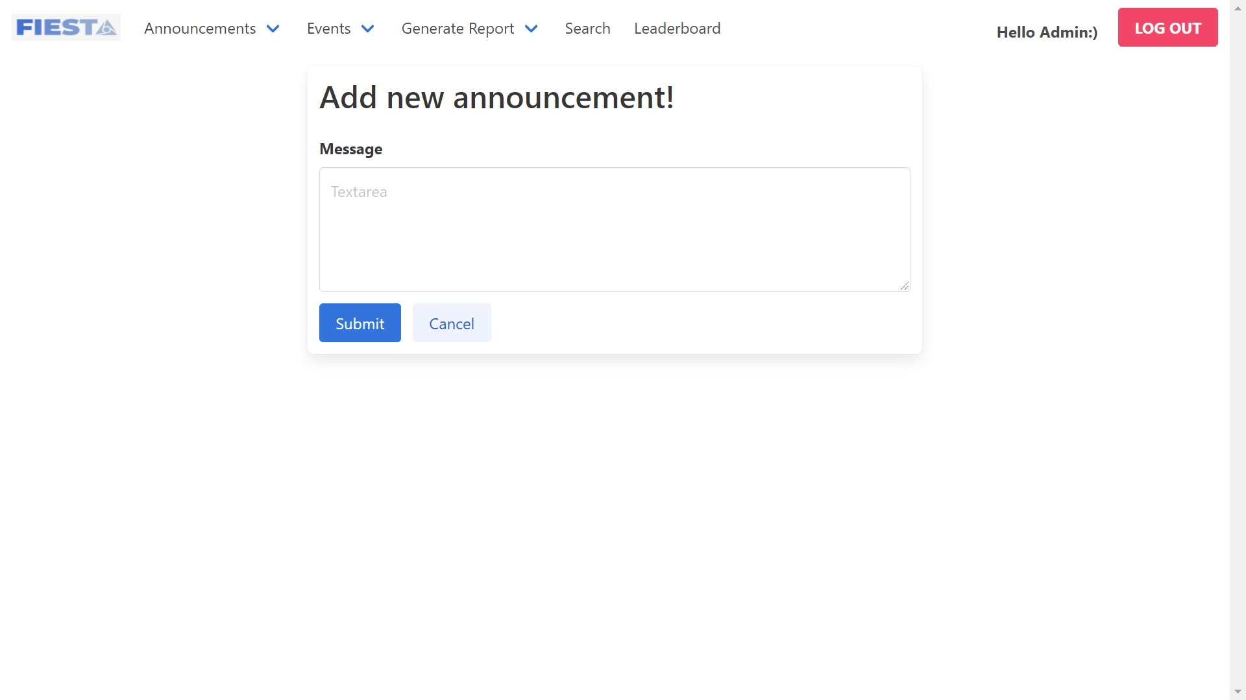
10. Modify the Announcement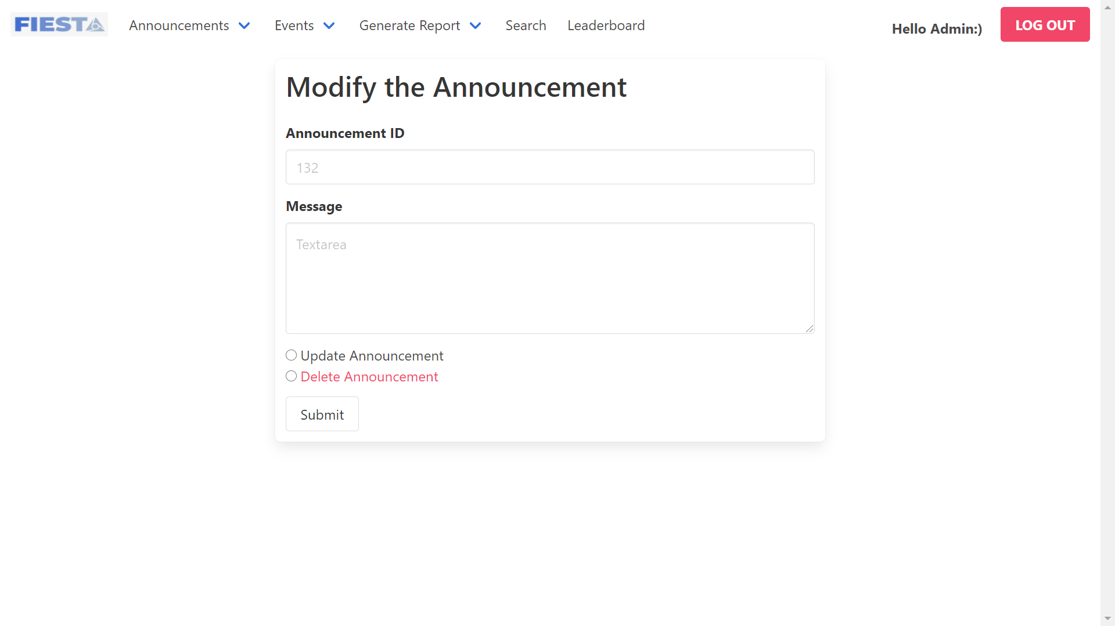
11. Portal to view latest news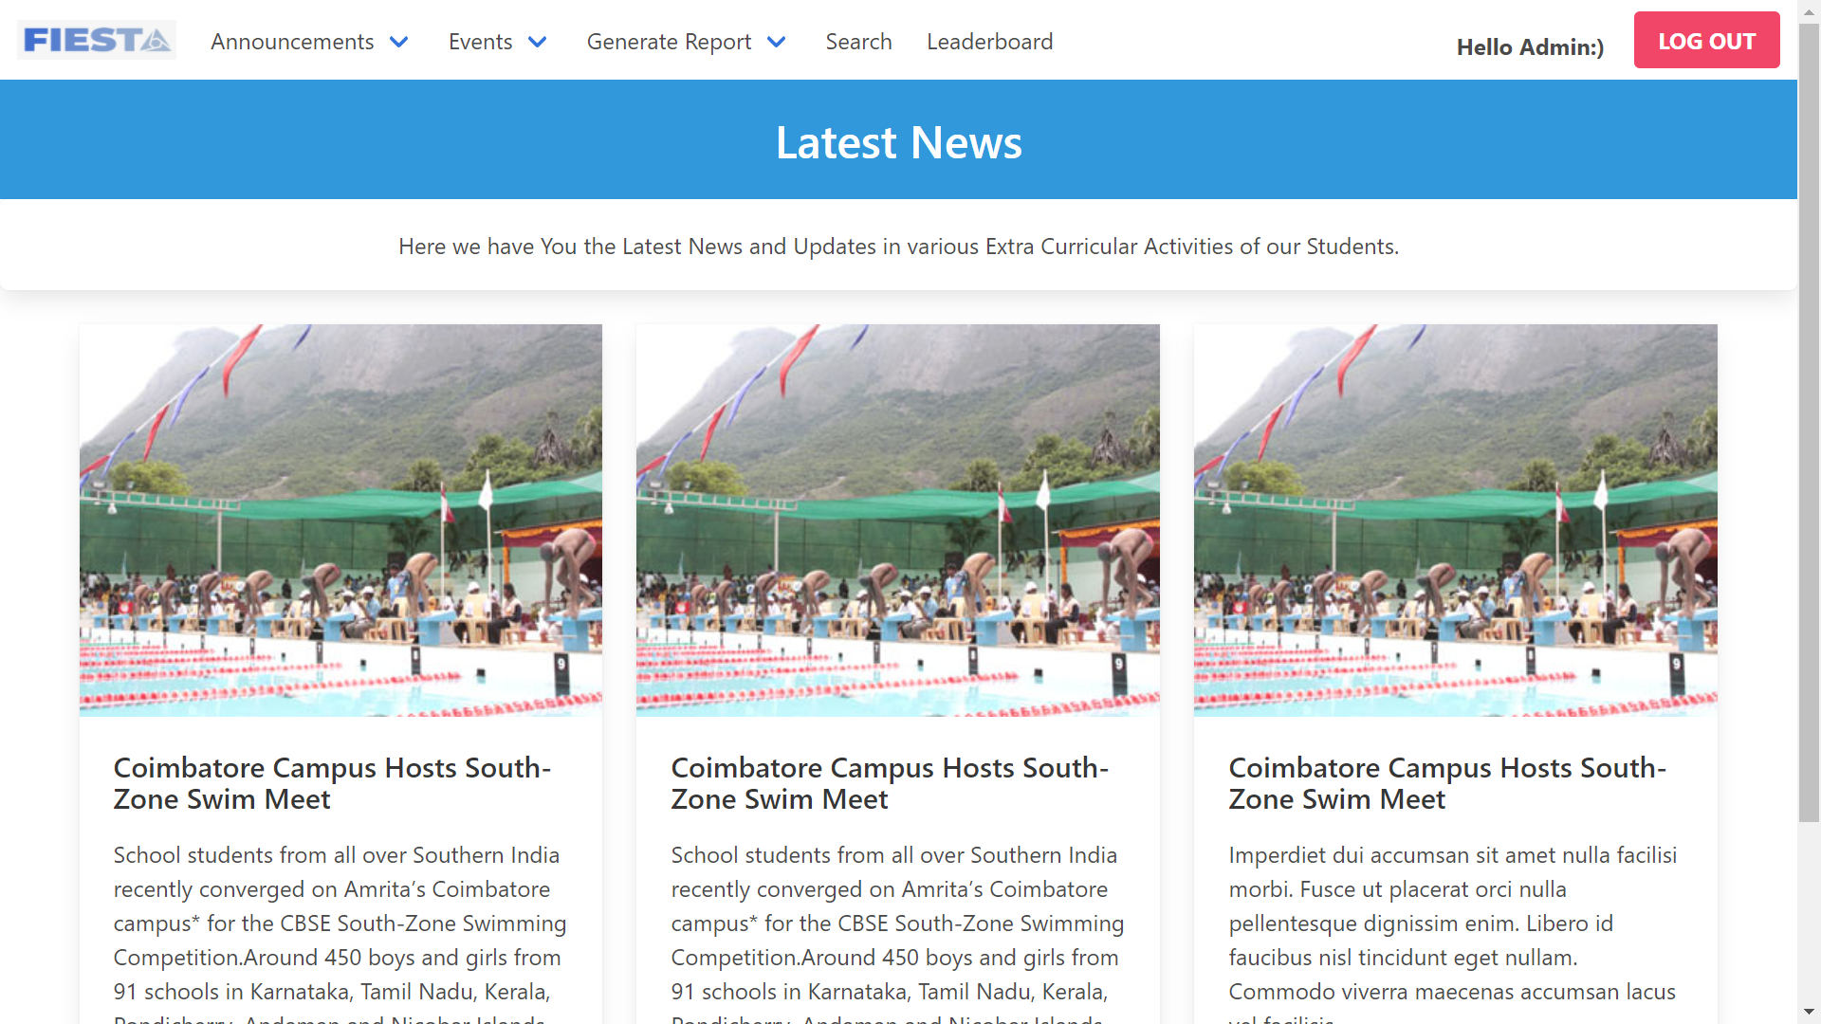
12. Form to create a new event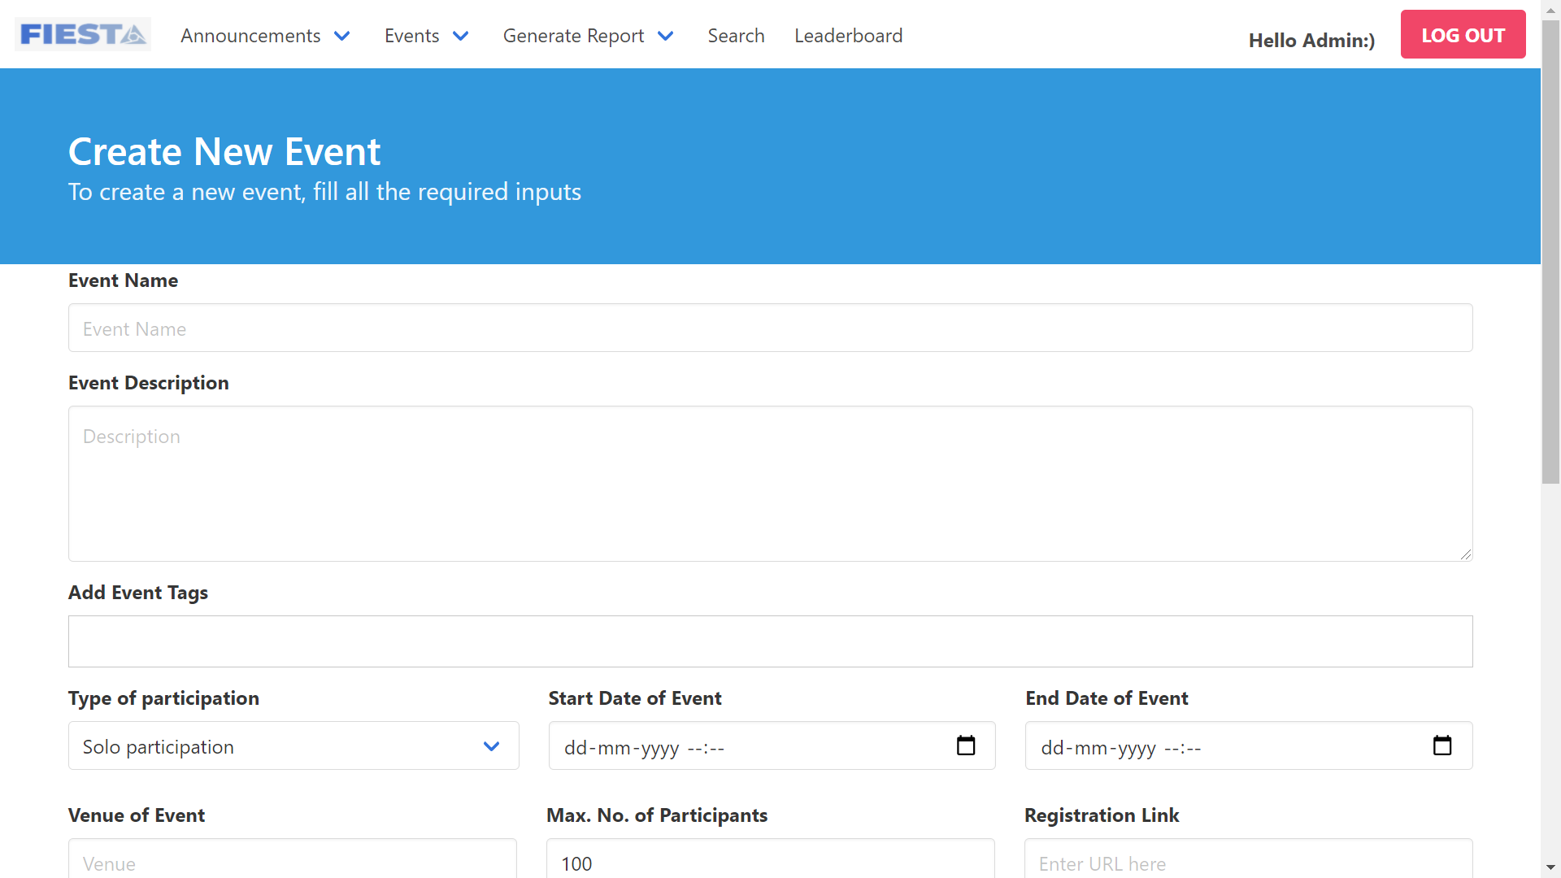
13. Form to update winners post event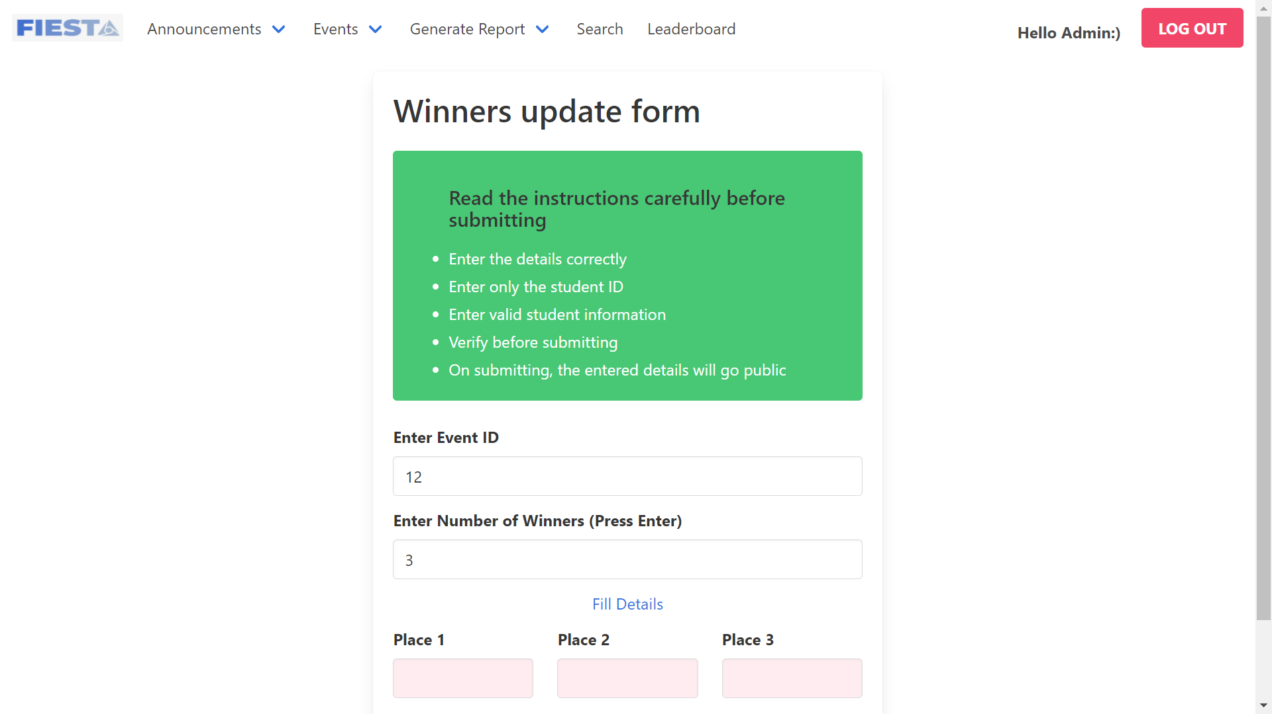
14. Form to update event details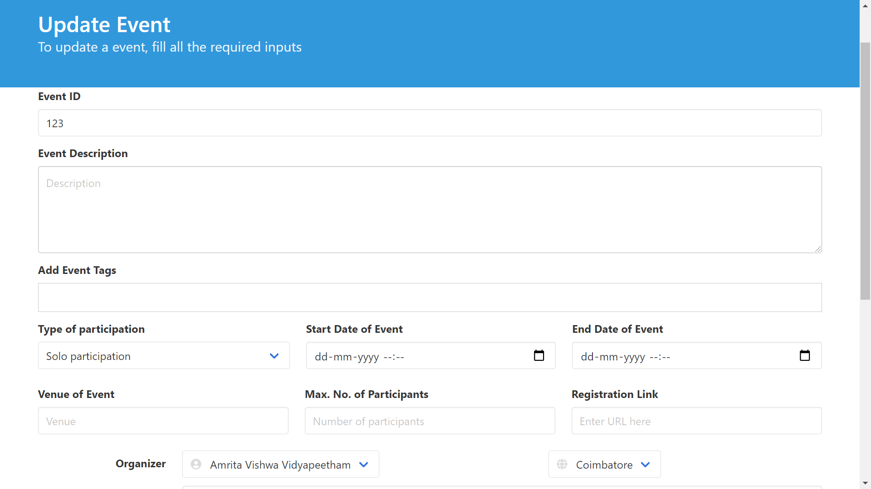
15. Event details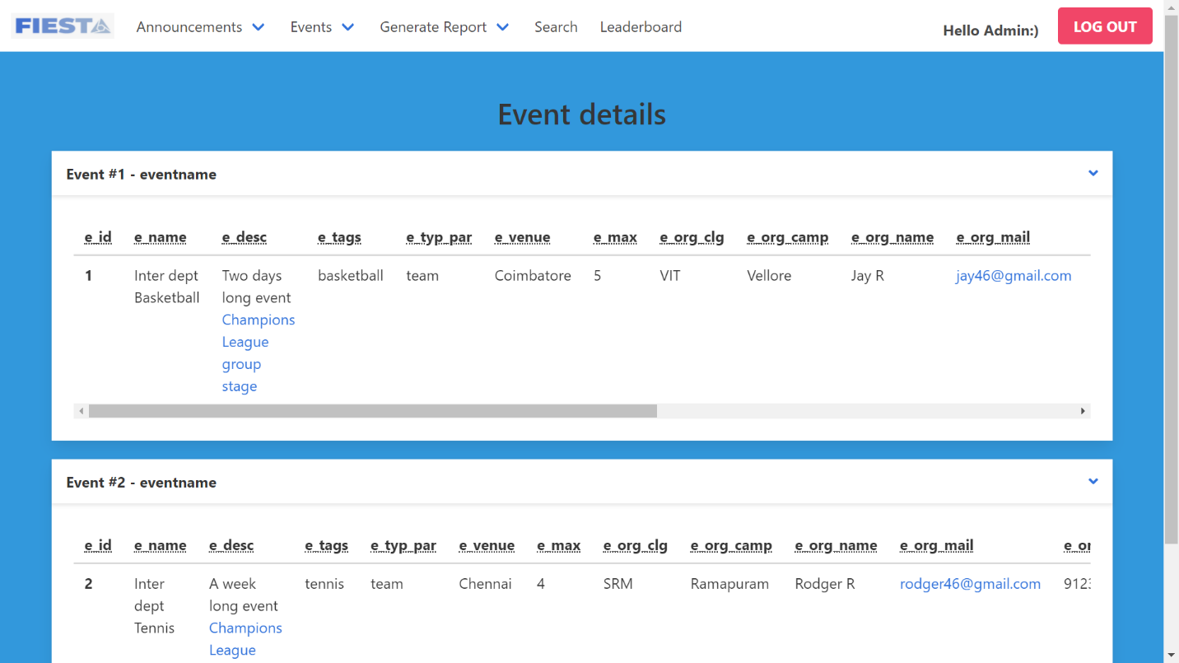
16. View student registrations event wise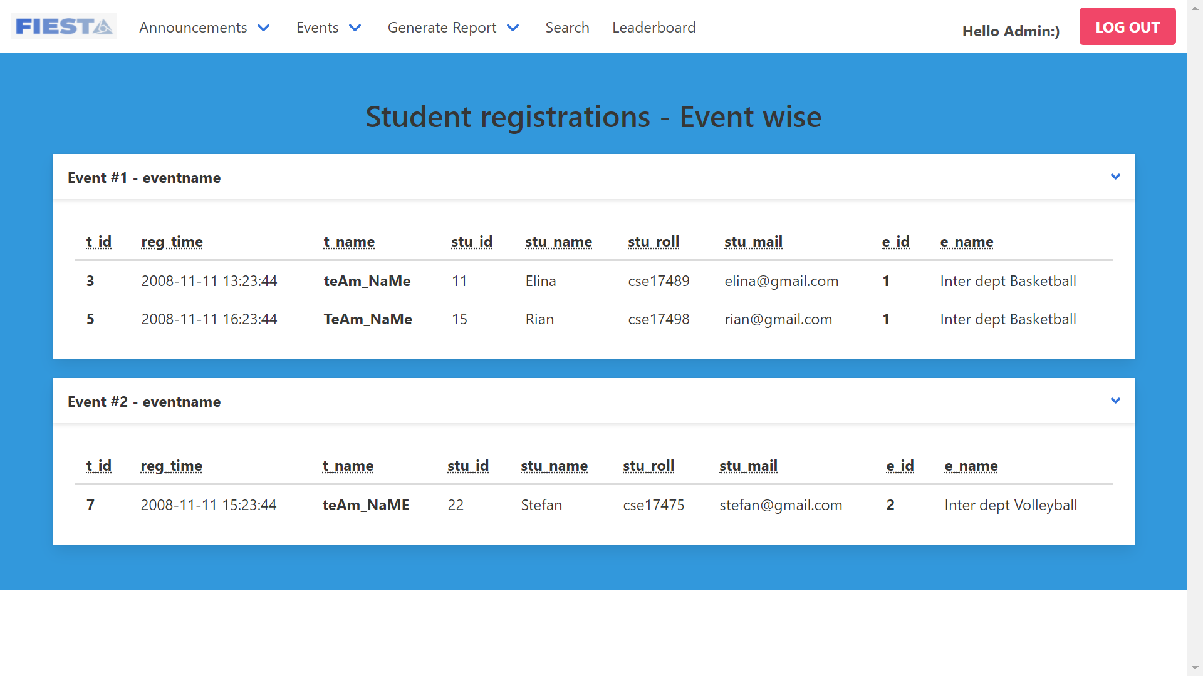
17. Generate report based on Input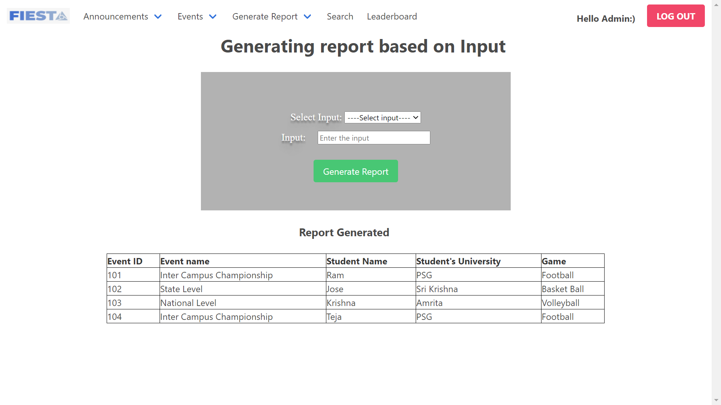
18. Generate report based on duration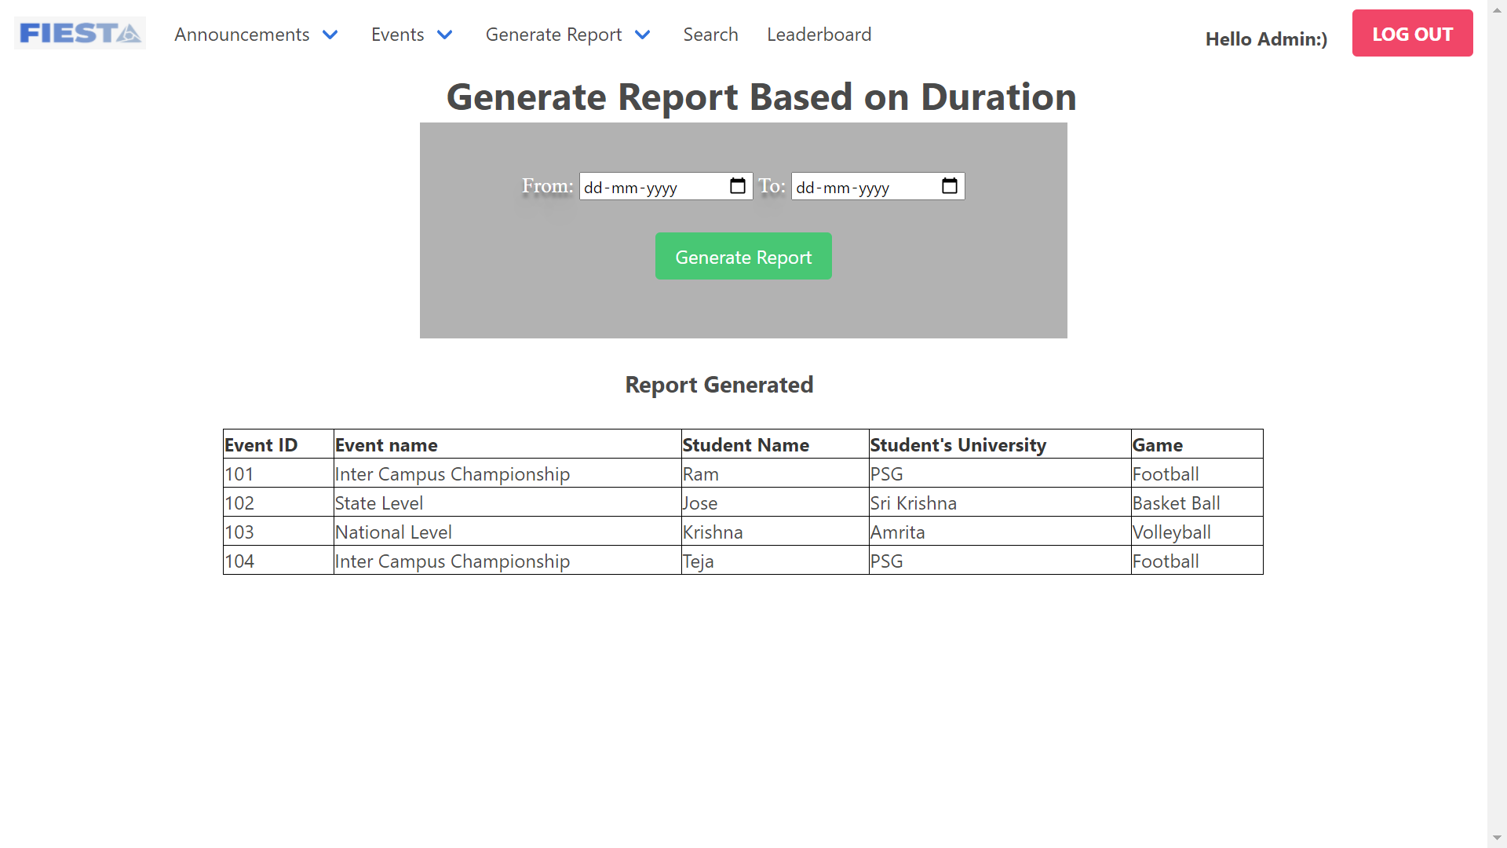
19. Search student based on student name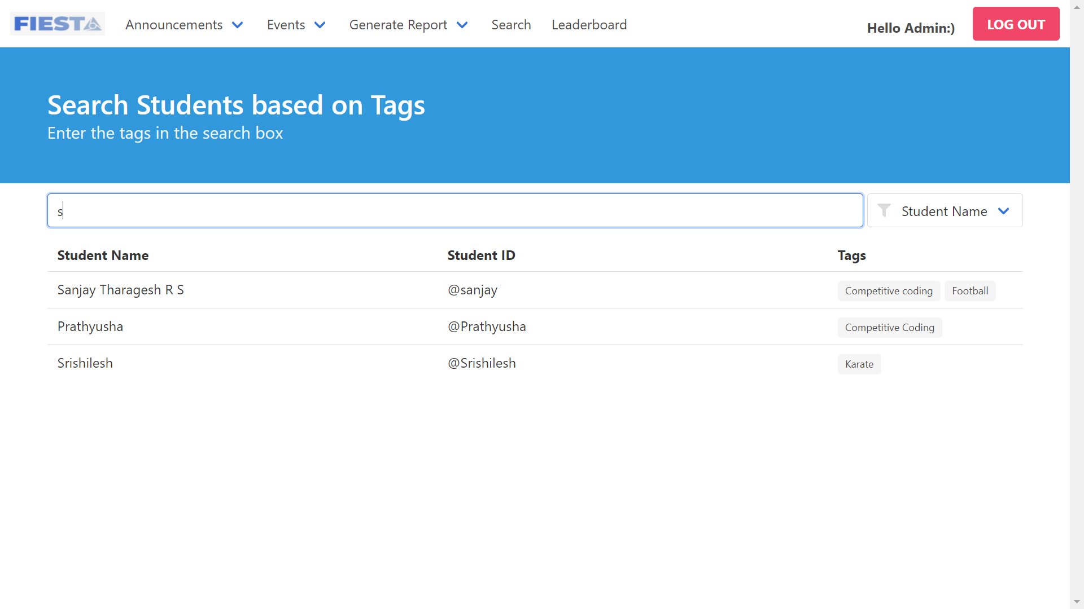
20. Search students based on tag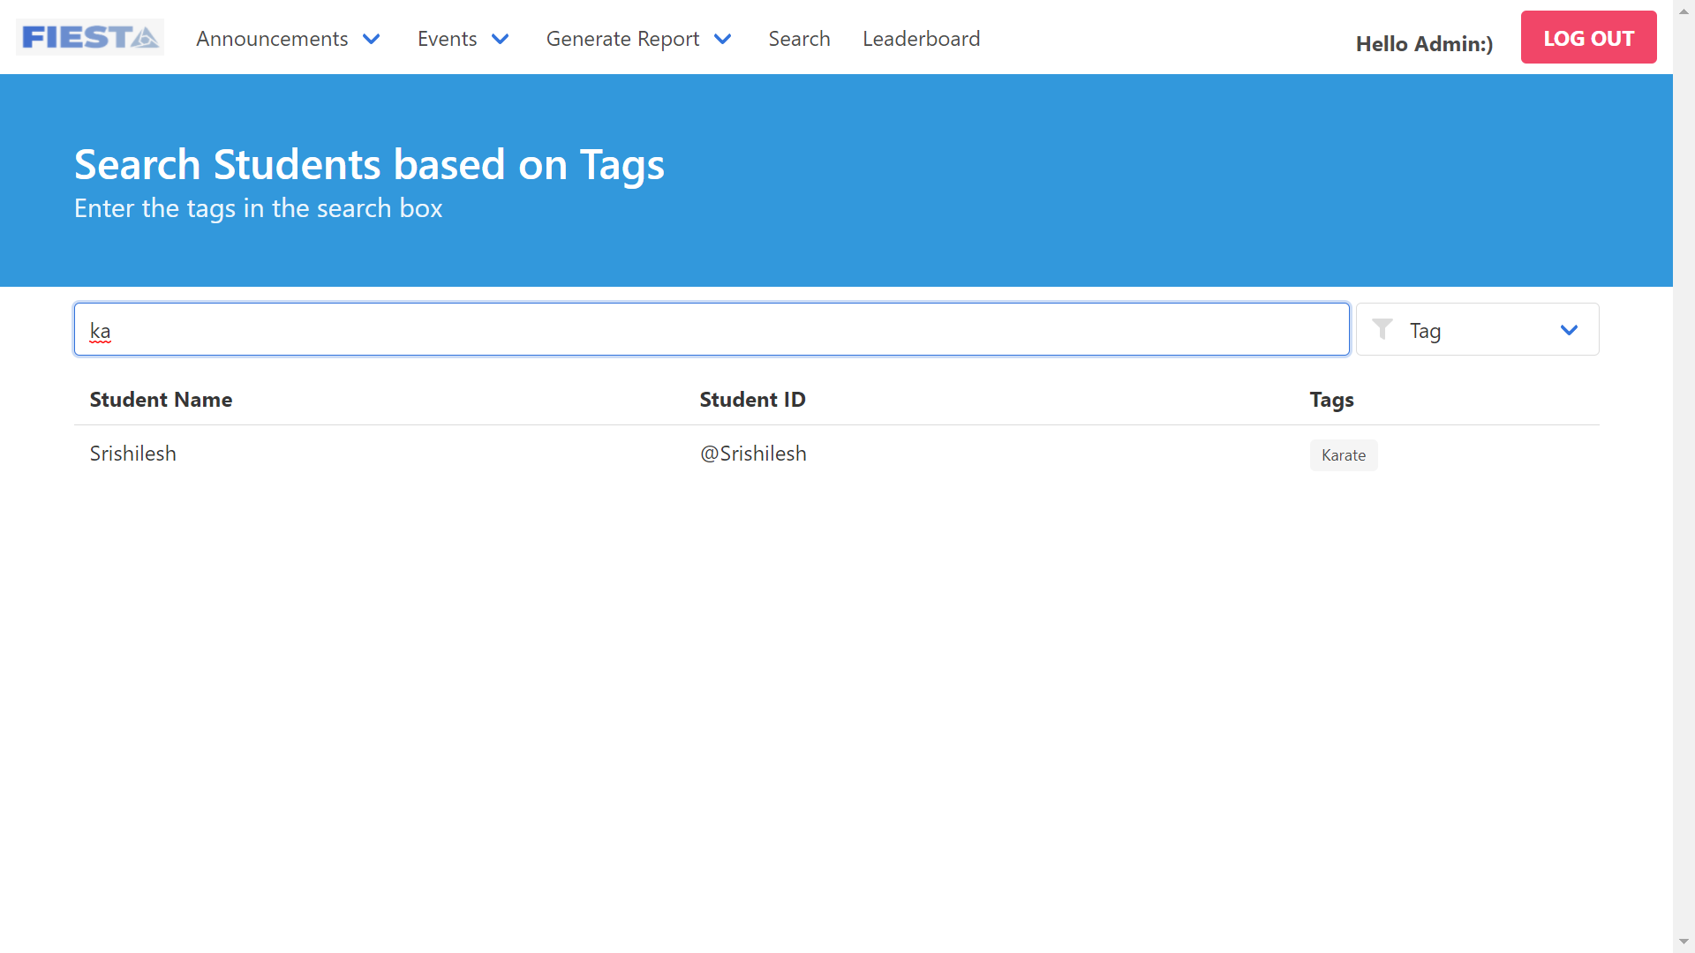
21. Leaderboard table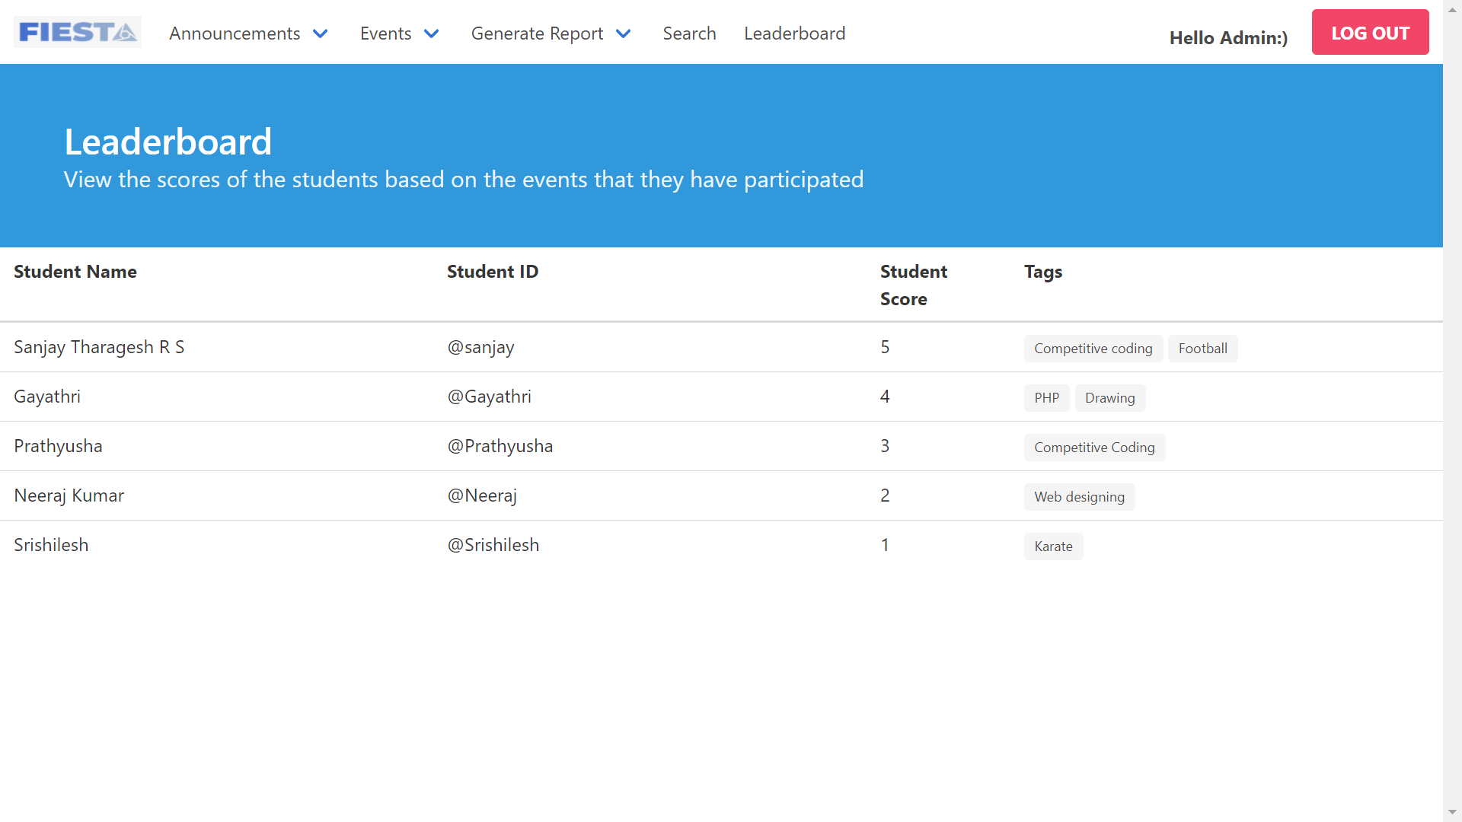
22. Event description page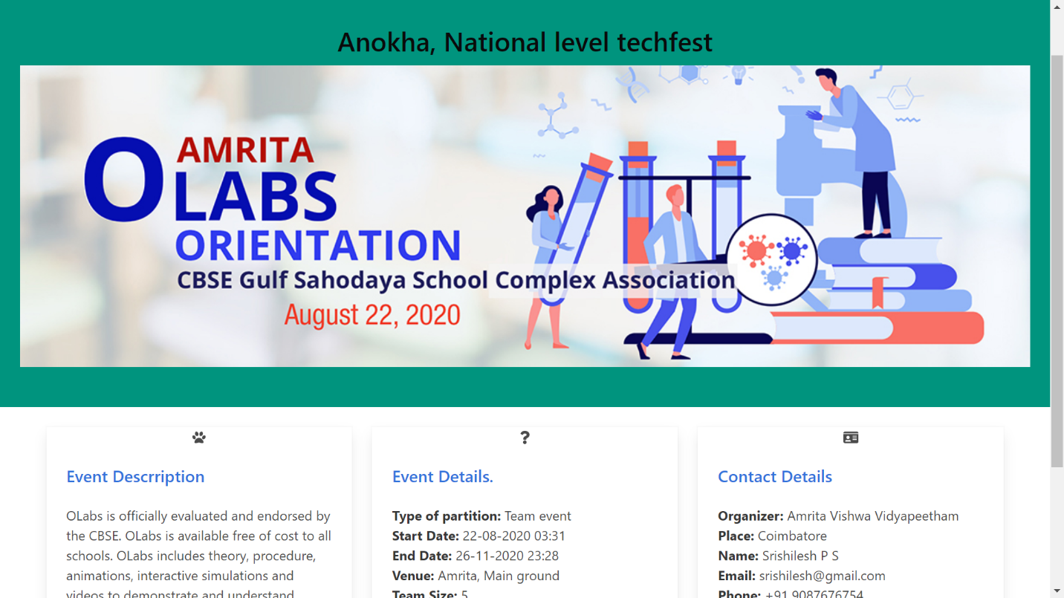
23. Student profile page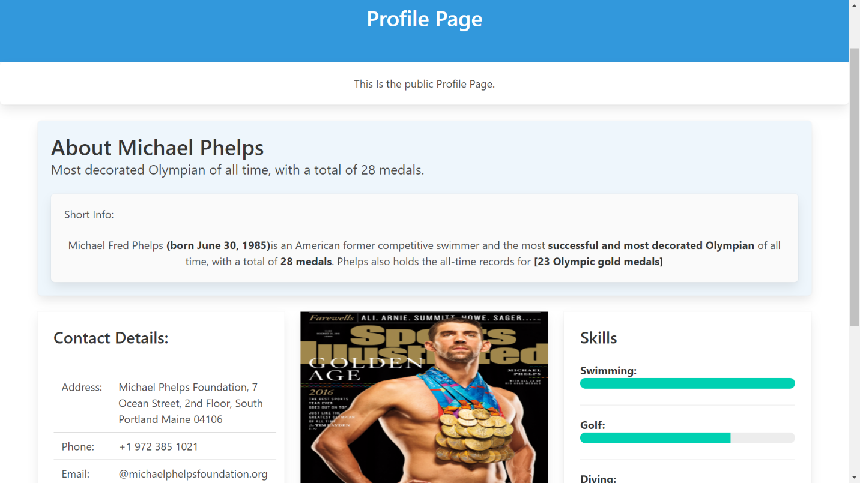
24. Update student details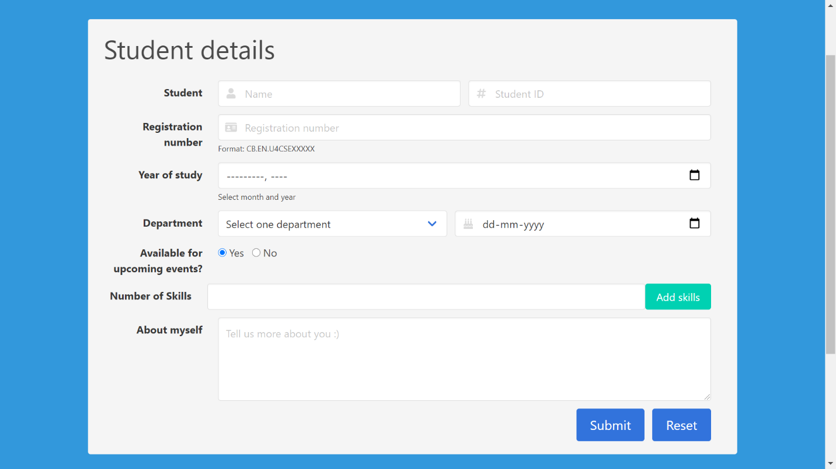
25. Update Student achievements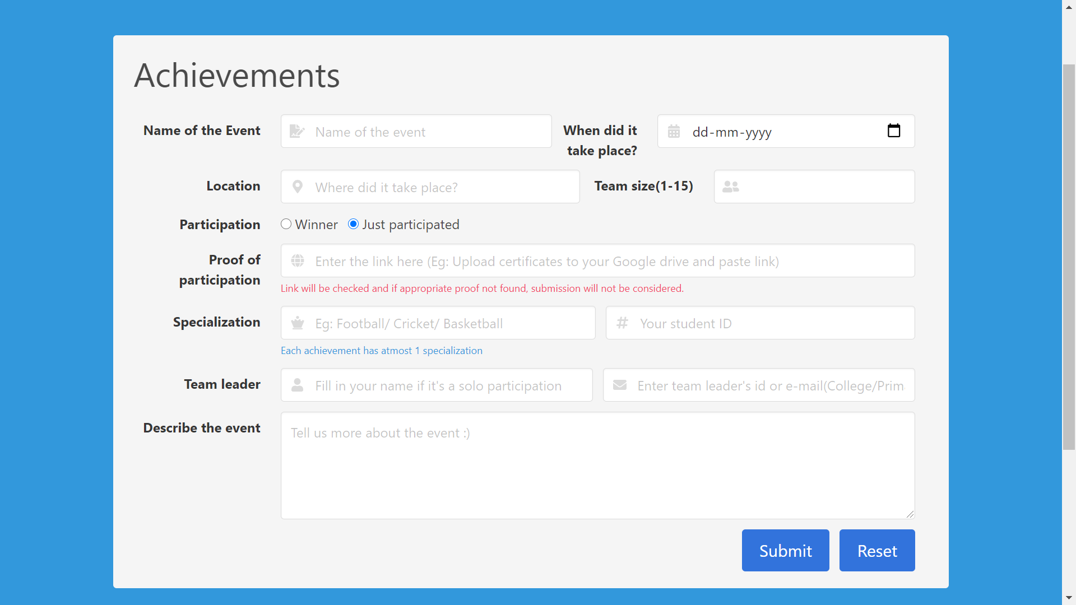
26. Update student contact details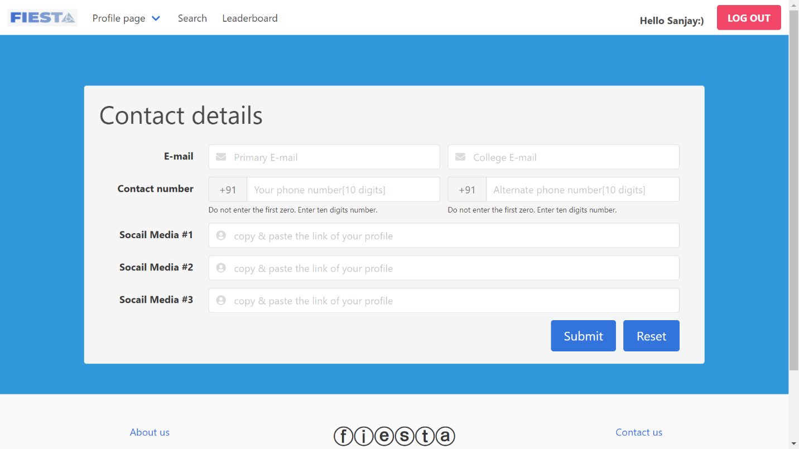

### Hardware Interfaces

*Not applicable to our project*

### Software Interfaces

* The EMS interfaces with other software components or products, including other systems, utility software, databases, and operating systems.
* EMS requires Java to be installed on the system, more specifically Java version 7 or 8 for its latest release.
* The software will be using Java servlets to communicate with MySQL hosted on AWS-RDS using JDBC.

## Functional Requirements

### LANDING PAGE

* **About Us**
* **Contact Us**
* **Admin Login**
* **Student Login**
* **Student Registration**

### STUDENT:

* **Public profile**: Profile for the World to view and admire
* **Private profile:** Student can edit his/her personal, achievements & contact details
* **View events**: View Past, present and upcoming events
* **One click registration:** Solo/Team registrations for Inter/Intra college events
* **Search for teammates**: Find your teammates based on skills
* **Student leader board**: Ranks the students based on participation and winning of events
* **View winners of the event:** Event wise winner list
* **Announcements section:** Get to know the latest updates regarding events
* **Search for teammates**: Find your teammates based on skills
* **Student leader board**: Ranks the students based on participation and winning of events
* **View winners of the event:** Event wise winner list
* **Announcements section:** Get to know the latest updates regarding events
* **Search for teammates**: Find your teammates based on skills
* **Student leader board**: Ranks the students based on participation and winning of events
* **View winners of the event:** Event wise winner list
* **Announcements section:** Get to know the latest updates regarding events

**3.3.3 ADMIN**:

* **Add/Remove/Update events**: Full access for event management
* **Generate Report**: Summarize events within a period (weekly, monthly and yearly)
* **View student registrations**: View all registrations in one portal
* **View events details:** Displays details eventwise
* **Event winner’s announcement**: Declare the winners
* **Student Leader board:** Controls how the students are ranked
* **Search students**: Pick the right students based on skills

## Use Case Model

### Use Case #1 (Landing page - U1)

**Purpose** – The main web interface for both admin and students to interact with the app.

**Requirements Traceability –** Admin and student should be from the same organization.

**Priority** - Medium

**Actors** – Student and Admin

**Use case diagram**

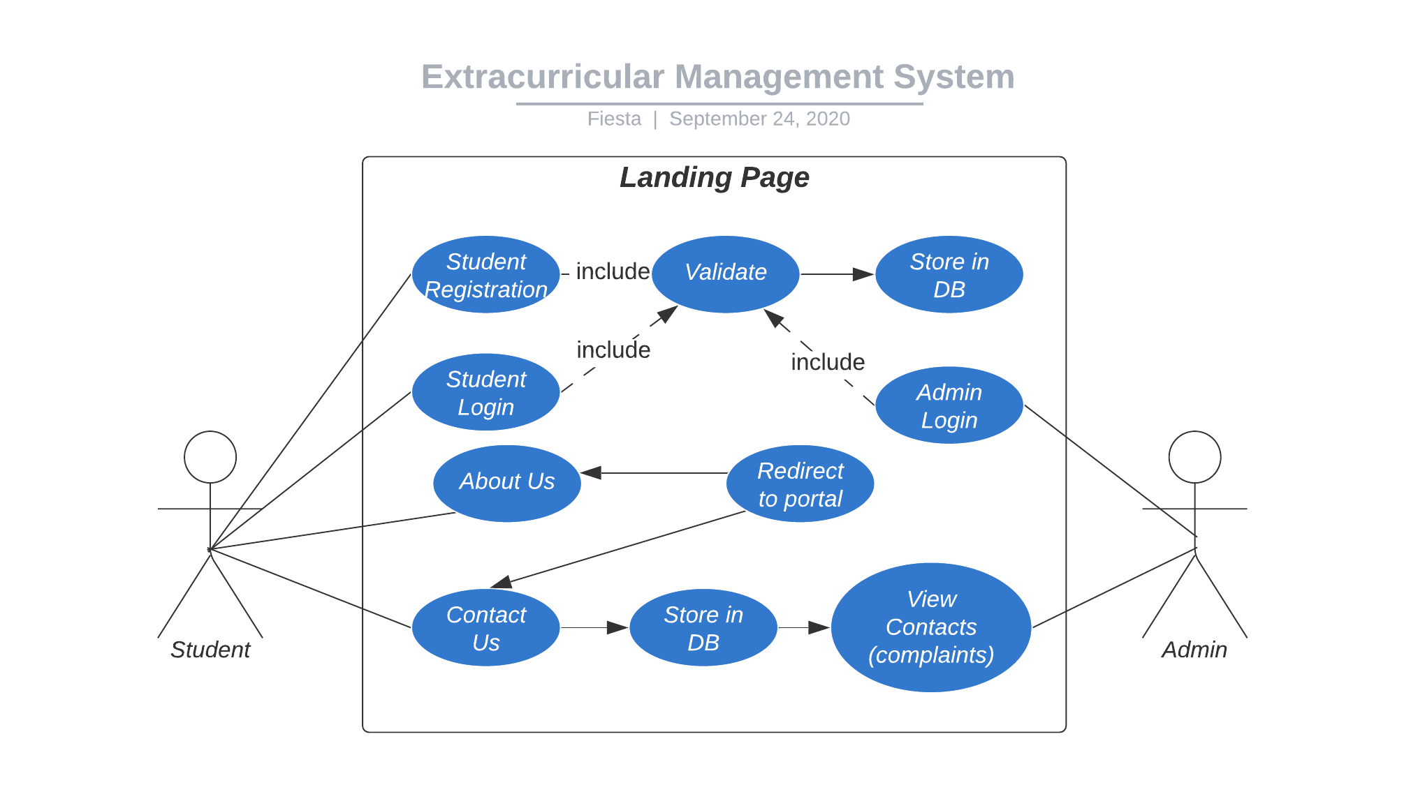

### Use Case #2 (Admin dashboard)

**Purpose** – Use cases related to admin.

**Priority** - High

**Preconditions** – Only limited number of admin access is provided for an organization.

**Actors** – Admin, Database(backend)

**Extends –** Admin login from landing page.

**Use case diagram**

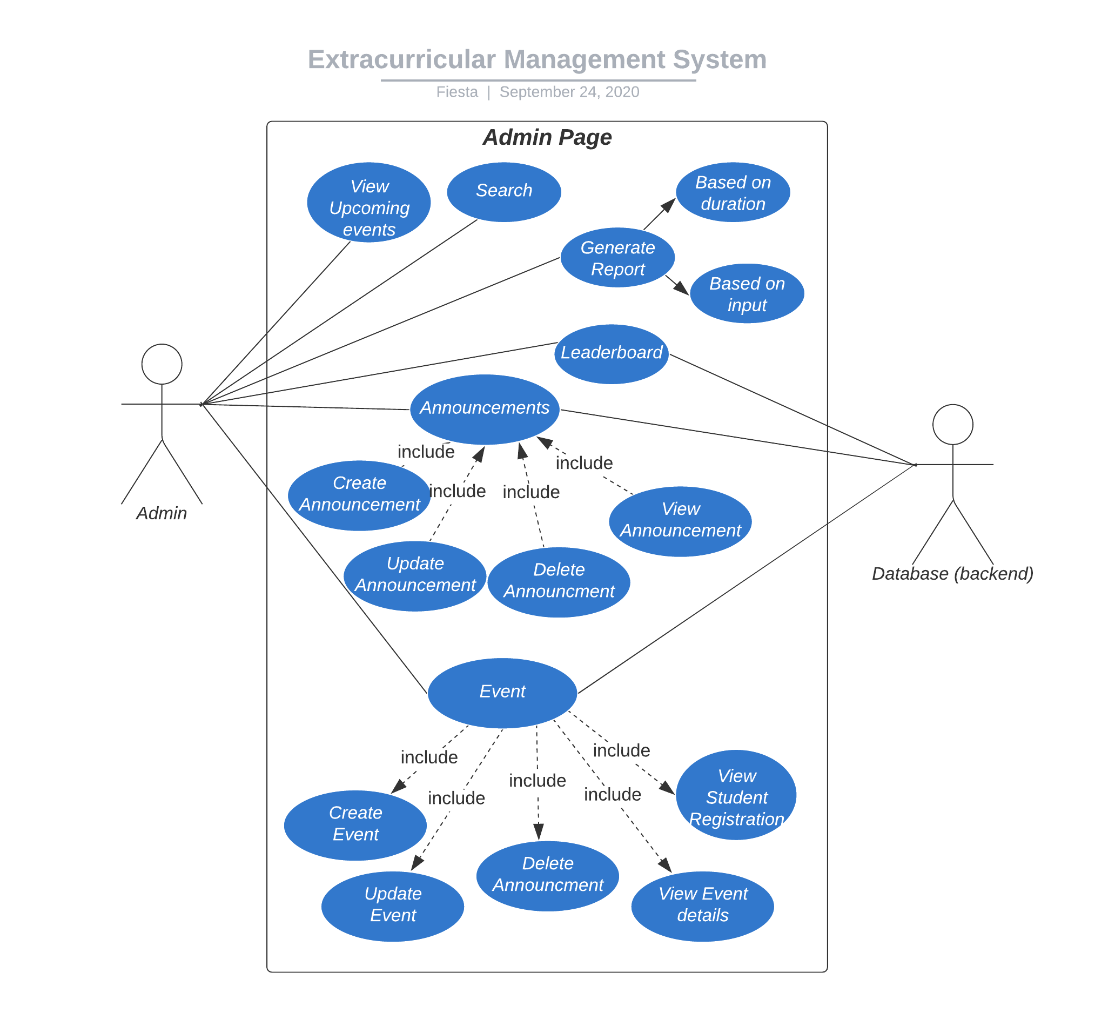

### Use Case #3 (Student dashboard)

**Purpose** – Portal for students to view, register, maintain profile for students.

**Priority** - High

**Preconditions** – Student must be member of same organization.

**Actors** – Student and Database.

**Extends –** Student login from landing page.

**Use case diagram**

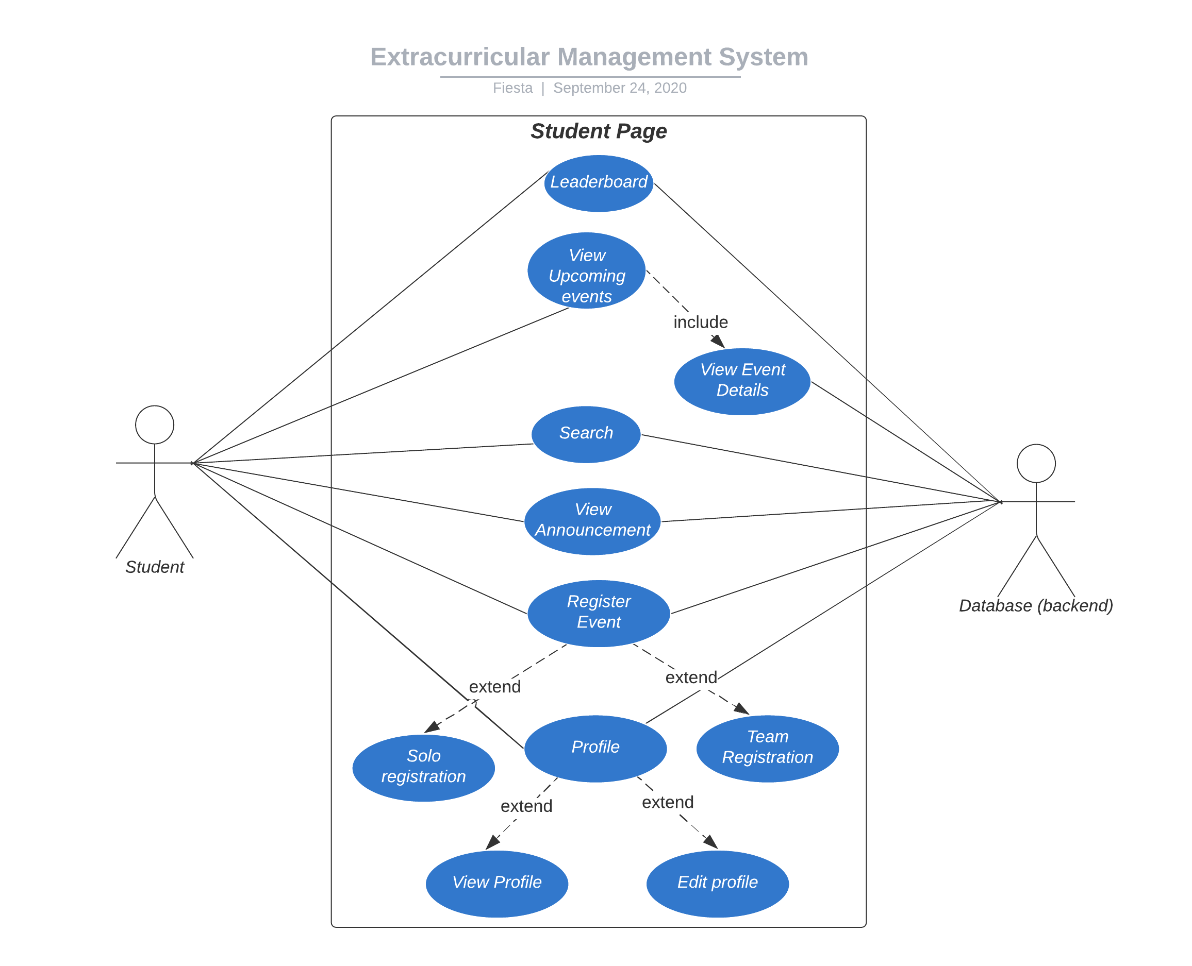

# Other Non-functional Requirements

## Performance Requirements

Web Application that is designed is user-friendly and contain many functionalities which make the tasks easier for end-users. When the entered input does not satisfy the mentioned validation rule, immediately a pop-up is appeared showing an error message, and there is no delay in raising an error. Dynamic fields for forms are made part of form when required to avoid confusion for the user and can be modified based on user’s requirement.

## Safety and Security Requirements

As the admin is the person who manages all the data related to events. It is made sure that there is no registration process available online, unless and until the organization provides needed credentials to the users. Validation rules are made mandatory for each form to avoid discrepancies and for the security purposes. A strong password can detain other than user to enter into the specific profile. Information of one user is not disclosed to other user, and it is made sure at the time of registration by mentioning specific terms and conditions.

## Software Quality Attributes

**4.3.1 Reliability :**

The data is managed by a database where the information is not lost and is not modified either, unless the user requests to.

**4.3.2 Adaptability:**

As the web-pages are designed using technologies like HTML, CSS etc. which is same to all the browsers, but using chrome is recommended due to some functionalities in HTML are not adaptable to browsers other than chrome.

**4.3.3: Usability:**

As the system is easy to handle and navigates in the most expected way with no delays, and is easily accessible with any device, which has internet and a browser.

# Other Requirements

*<This section is* ***Optional.*** *Define any other requirements not covered elsewhere in the SRS. This might include database requirements, internationalization requirements, legal requirements, reuse objectives for the project, and so on. Add any new sections that are pertinent to the project.>*

**Appendix A – Data Dictionary**

*<Data dictionary is used to track all the different variables, states and functional requirements that you described in your document. Make sure to include the complete list of all constants, state variables (and their possible states), inputs and outputs in a table. In the table, include the description of these items as well as all related operations and requirements.>*

**Appendix B - Group Log**

*<Please include here all the minutes from your group meetings, your group activities, and any other relevant information that will assist in determining the effort put forth to produce this document>*